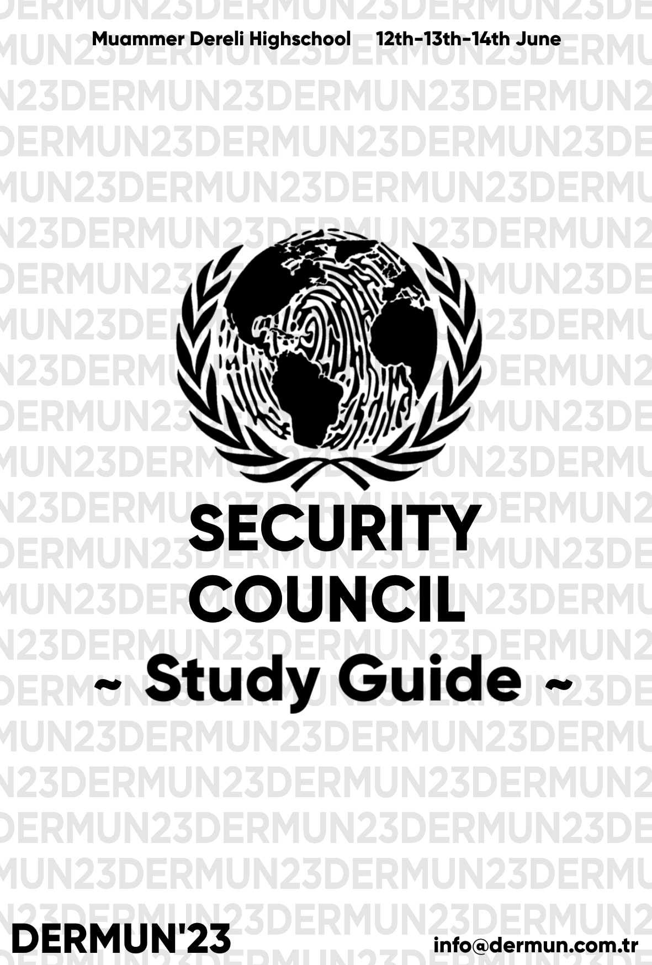DERMUN’22

United Nations Security Council

STUDY GUIDE

# TABLE OF CONTENTS

### **1. Letter of the Secretary-General 2.Letter of the chair board**

1. **Introduction To The Committee**

3.1 Member States

1. **Enlargement of NATO**
   1. Criteria and Process
      1. Article 10 and the Open Door Policy
      2. Membership Action Plan
   2. Past Enlargements
      1. Cold War
      2. Adriatic Charter
   3. Current status
      1. Finland
      2. Sweden
      3. Ukraine
      4. Georgia
   4. Membership debates
      1. Austria2.4.2 Kosovo
      2. Moldova
      3. Malta
      4. Serbia
2. **Past enlargements**
   1. ColdWar
   2. Post-Cold War
3. **Milestones**
4. **History of the security council**
5. **Bibliography**
6. **Chair Board’s Contac**

**Letter from the Secretary-General**

Dear Participants,

On behalf of DERMUN’23 Model United Nations (MUN) Conference, it is our great pleasure to extend a warm welcome to all participants attending this esteemed event. As the Secretary-General’s, we are honored to have the opportunity to address you all and witness the culmination of your diligent preparations and intellectual prowess.

DERMUN’23 Conference serves as a platform for aspiring young leaders like yourselves to engage in substantive discussions, exchange diverse perspectives, and collectively seek solutions to the world's most pressing issues. This year, we have meticulously curated a diverse range of committees to stimulate robust debates and foster innovative thinking. We have got five committees,3 English-2 Turkish, which includes General Assembly(GA) like SOCHUM and Special Committees.

We are confident that DERMUN’23 Conference will not only provide you with an enriching experience but also enable you to forge lifelong connections with like-minded individuals who share your passion for international affairs. Embrace the diversity of perspectives within this conference, seize every opportunity for collaboration, and let your ideas inspire positive change.

*Eylül Yaman*

*Kenan Mirzaoğlu*

**Letter from the Chairboard**

Esteemed delagates,

Salututions, we are the chair board of United Nations Security Council; Defne Canbaz as your chair and Ezgi Eren as your co-chair. It is an absolute honor to invite and welcome you all.

First of all we are aware of its most of yours first MUN experience. So we don’t want you to be afraid of speaking, taking action or making any mistakes. The starting point of your study has been given in this guide. But we strongly advice every delagation of UN Security Council to look up more articles throughout the prep- process. We request you not to forget MUN rules forbid getting out of your countries politic ideas. Make sure you know that the aim of this conference to find the solution of our problem in an officious discussion environment finally concluding it with our resolution paper.

As a summary, whether vou have attended previous MUN conferences or not, we're looking forward to unite every and each one of you at our school with having an aim of providing you an outstanding experience where you'll get the chance to gain remarkable memories and spread your wings. Hope to see you soon!

*P.S: If you have any questions DO NOT hesitate asking us.*

Sincerely,

The Chairboard of United Nations Security Council

**Member States**

1)Russian Federation

2)United States of America

3)China

4)France

5)United Kingdom

6)Bosnia and Herzegovina

7)Finland

8)Sweden

9)Ukraine

10)Georgia

11)Austria

12)Kosovo

13)Moldova

14)Malta

15)Serbia

1. **Inroduction to United Nations Security Council**

The United Nations Security Council (UNSC) is one of the six principal organs of the United Nations (UN)[ and is charged with ensuring international peace and security, recommending the admission of new UN members to the General Assembly, and approving any changes to the UN Charter.Its powers include establishing peacekeeping operations, enacting international sanctions, and authorizing military action.

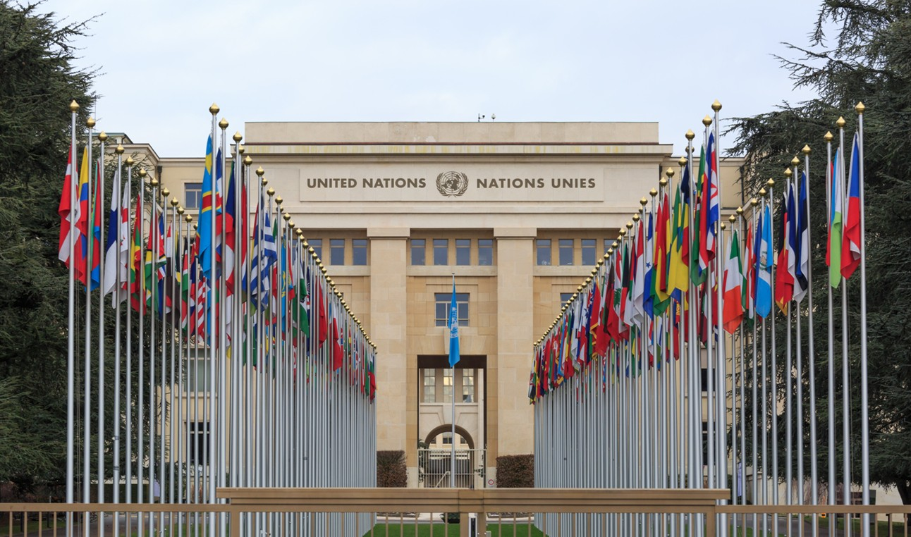Like the UN as a whole, the Security Council was created after World War II to address the failings of the League of Nations in maintaining world peace. It held its first session on 17 January 1946 but was largely paralyzed in the following decades by the Cold War between the United States and the Soviet Union (and their allies). Nevertheless, it authorized military interventions in the Korean War and the Congo Crisis and peacekeeping missions in Cyprus, West New Guinea, and the Sinai Peninsula. With the collapse of the Soviet Union, UN peacekeeping efforts increased dramatically in scale, with the Security Council authorizing major military and peacekeeping missions in Kuwait, Namibia, Cambodia, Bosnia and Herzegovina, Rwanda, Somalia, Sudan, and the Democratic Republic of the Congo.

The United Nations Security Council is often seen as the most important and most powerful entity within the United Nations. This organ is comprised of fifteen member states, 5 of which have permanent seats, and a UN veto power. These states are the United States, the UK, Russia, China, and France. The other ten seats are non- permanent seats, and these seats do not have a veto power in the United Nations.

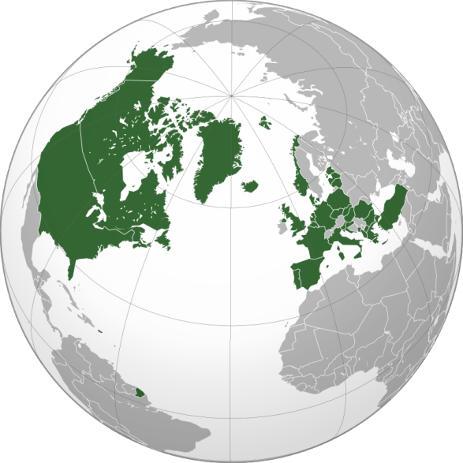The other ten members are elected on a regional basis for a term of two years. The body's presidency rotates monthly among its members.

NATO is a military alliance of twenty-eight European and two North American countries that constitutes a system of collective defense.

NATOs aims can be collected in *two* different titles:

**> POLITICAL** - “NATO promotes democratic values and enables members to consult and cooperate on defence and security-related issues to solve problems, build trust and, in the long run, prevent conflict.”

**- > MILITARY** - “NATO is committed to the peaceful resolution of disputes. If diplomatic efforts fail, it has the military power to undertake crisis- management operations. These are carried out under the collective defence clause of NATO's founding treaty - Article 5 of the Washington Treaty or under a United Nations mandate, alone or in cooperation with other countries and international organisations”

## Enlargement of NATO

The process of joining the alliance is governed by Article 10 of the North Atlantic Treaty, which allows for the invitation of "other European States" only and by subsequent agreements. Countries wishing to join must meet certain requirements and complete a multi-step process involving political dialog and military integration. The accession process is overseen by the North Atlantic Council, NATO's governing body. NATO was formed in 1949 with twelve founding members and has added new members eight times. The first additions were Greece and Turkey in 1952. In May 1955, West Germany joined NATO, which was one of the conditions agreed to as part of the end of the country's occupation by France, the United Kingdom, and the United States, prompting the Soviet Union to form their own collective security alliance

(commonly called the Warsaw Pact) later that month. Following the

end of the Franco regime, newly-democratic Spain chose to join NATO in 1982.

In 1990, the Soviet Union and NATO reached an agreement that a reunified Germany would join NATO under West Germany's pre-existing membership. However, restrictions were agreed to on the deployment of NATO troops on former East German territory. The dissolution of the Soviet Union in 1991 led many former Warsaw Pact and post-Soviet states to initiate discussions about joining NATO. Poland, Hungary, and the Czech Republic became NATO members in 1999, amid much debate within NATO itself and Russian opposition. NATO then formalized the process of joining the organization with "Membership Action Plans", which aided the accession of seven Central and Eastern Europe countries shortly before the 2004 Istanbul summit: Bulgaria, Estonia, Latvia, Lithuania, Romania, Slovakia, and Slovenia. Two countries on the Adriatic Sea—Albania and Croatia—joined on 1 April 2009 before the 2009 Strasbourg–Kehl summit. The most recent member states to join NATO were Montenegro on 5 June 2017 and North Macedonia on 27 March 2020

In July 2022, NATO invited Finland and Sweden to join the organization, and the ratification process for the two countries is in progress. In September 2022, Ukraine applied for NATO membership.As of October 2022, two additional states have formally informed NATO of their membership aspirations: Bosnia and Herzegovina and Georgia.Kosovo also aspires to join NATO.Joining the alliance is a debate topic in several other European countries outside the alliance, including Austria, Ireland, Malta, Moldova, and Serbia.

## Criteria and Process

#### Article 10 and the Open Door Policy

The [North Atlantic Treaty](https://en.wikipedia.org/wiki/North_Atlantic_Treaty) is the basis of the organization, and, as such, any changes including new membership requires ratification by all current signers of the treaty. The treaty's Article 10 describes how non-member states may join [NATO](https://en.wikipedia.org/wiki/NATO):

The Parties may, by unanimous agreement, invite any other European State in a position to further the principles of this Treaty and to contribute to the security of the North Atlantic area to accede to this Treaty. Any State so invited may become a Party to the Treaty by depositing its instrument of accession with the Government of the United States of America. The Government of the United States of America will inform each of the Parties of the deposit of each such instrument of accession.[79]

*“ NATO’s door remains open to any European country in a position to undertake the commitments and obligations of membership, and contribute to security in the Euro-*

*Atlantic area. Since 1949, NATO’s membership has increased from 12 to 30 countries through eight rounds of enlargement. The Republic of North Macedonia became the latest country to join the Alliance on 27 March 2020. Currently, five partner countries have declared their aspirations to NATO membership: Bosnia and Herzegovina, Finland, Georgia, Sweden and Ukraine. Finland and Sweden completed accession talks, and Allies signed the Accession Protocols for both countries in July 2022. They are now official Invitees and attend NATO meetings.”*

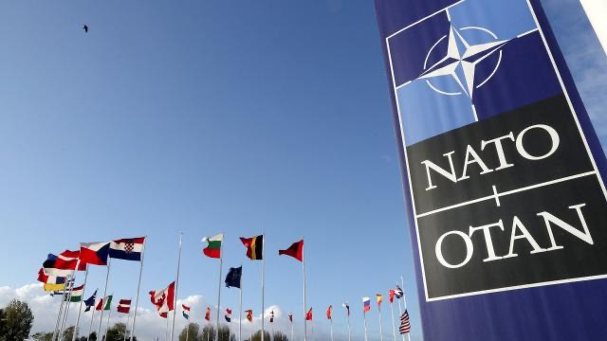

#### Membership Action Plan

The biggest step in the formalization of the process for inviting new members came at the [1999 Washington summit](https://en.wikipedia.org/wiki/1999_Washington_summit) when the Membership Action Plan (MAP) mechanism was approved as a stage for the current members to regularly review the formal applications of aspiring members. A country's participation in MAP entails the annual presentation of reports concerning its progress on five different measures:

* + - * Willingness to settle international, ethnic or external territorial disputes by peaceful means, commitment to the rule of law and human rights, and democratic control of armed forces
      * Ability to contribute to the organization's defense and missions
      * Devotion of sufficient resources to armed forces to be able to meet the commitments of membership
      * Security of sensitive information, and safeguards ensuring it
      * Compatibility of domestic legislation with NATO cooperation

NATO provides feedback as well as technical advice to each country and evaluates its progress on an individual basis. Once members agree that a country meets the requirements, NATO can issue that country an invitation to begin accession talks. The final accession process, once invited, involves five steps leading up to the signing of the accession protocols and the acceptance and ratification of those protocols by the governments of the current NATO members.

## Past Enlargements

#### Cold War

Twelve countries were part of the founding of NATO: [Belgium](https://en.wikipedia.org/wiki/Belgium), [Canada,](https://en.wikipedia.org/wiki/Canada) [Denmark](https://en.wikipedia.org/wiki/Denmark), [France,](https://en.wikipedia.org/wiki/France) [Iceland](https://en.wikipedia.org/wiki/Iceland), [Italy,](https://en.wikipedia.org/wiki/Italy) [Luxembourg,](https://en.wikipedia.org/wiki/Luxembourg) [the Netherlands,](https://en.wikipedia.org/wiki/The_Netherlands) [Norway,](https://en.wikipedia.org/wiki/Norway) [Portugal,](https://en.wikipedia.org/wiki/Portugal) the [United](https://en.wikipedia.org/wiki/United_Kingdom) [Kingdom,](https://en.wikipedia.org/wiki/United_Kingdom) and the [United State](https://en.wikipedia.org/wiki/United_States)s. The start of the [Cold War between 1947 and 1953](https://en.wikipedia.org/wiki/Cold_War_(1947%25E2%2580%25931953)) saw an ideological and economic divide between the capitalist states of Western Europe backed by United States with its [Marshall Plan](https://en.wikipedia.org/wiki/Marshall_Plan), and the communist states of Eastern Europe, backed by the [Soviet Union](https://en.wikipedia.org/wiki/Soviet_Union).

As such, opposition to Soviet-style communism became a defining characteristic of the

organization and the [anti-communist](https://en.wikipedia.org/wiki/Anti-communism) governments of [Greec](https://en.wikipedia.org/wiki/Greece)e, which had just fought a [civil war](https://en.wikipedia.org/wiki/Greek_Civil_War) against a [pro-communist army,](https://en.wikipedia.org/wiki/Democratic_Army_of_Greece) and [Turkey](https://en.wikipedia.org/wiki/Turkey) came under internal and external pressure to join the alliance, which both did in February 1952.

The United States, France, and the United Kingdom initially agreed to end [their](https://en.wikipedia.org/wiki/Allied-occupied_Germany) [occupation of Germany](https://en.wikipedia.org/wiki/Allied-occupied_Germany) in May 1952 that the new Federal Republic of Germany,

commonly called [West Germany,](https://en.wikipedia.org/wiki/West_Germany) would join NATO, due to concerns over a non- aligned West Germany being [allowed to rearm.](https://en.wikipedia.org/wiki/West_German_rearmament)

France, however, delayed the start of the process, in part on the condition that a [referendum be held in Saar](https://en.wikipedia.org/wiki/1955_Saar_Statute_referendum) on its future status, and a revised treaty was signed on 23 October 1954

Ratification of their membership was completed in May 1955 That month the Soviet Union established its own collective defense alliance, commonly called the [Warsaw](https://en.wikipedia.org/wiki/Warsaw_Pact) [Pac](https://en.wikipedia.org/wiki/Warsaw_Pact)t, in part as a response to West German membership in NATO.

In 1975, [Spain](https://en.wikipedia.org/wiki/Spain) began a [transition to democracy](https://en.wikipedia.org/wiki/Spanish_transition_to_democracy), and came under international pressure to normalize relations with other western democracies. In February 1981 Prime Minister and campaigned strongly for NATO membership, in part to improve civilian control over the military, and Spain's NATO membership was approved in June 1982.

During the mid-1980s the strength and cohesion of the Warsaw Pact, which had served as the main institution rivaling NATO, began to deteriorate. By 1989 the [Soviet](https://en.wikipedia.org/wiki/Soviet_Union) [Union](https://en.wikipedia.org/wiki/Soviet_Union) was unable to stem the democratic and nationalist movements which were rapidly gaining ground. [Poland held multiparty elections](https://en.wikipedia.org/wiki/1989_Polish_legislative_election) in June 1989 that ousted the Soviet allied [Polish Workers' Party](https://en.wikipedia.org/wiki/Polish_United_Workers%2527_Party) and the peaceful opening of the [Berlin Wall](https://en.wikipedia.org/wiki/Berlin_Wall) that November symbolized the end of the Warsaw Pact as a way of enforcing Soviet control. The [fall of the Berlin Wall](https://en.wikipedia.org/wiki/Fall_of_the_Berlin_Wall) is recognized to be the end of the Cold War and ushered in a new period for Europe and NATO enlargement.

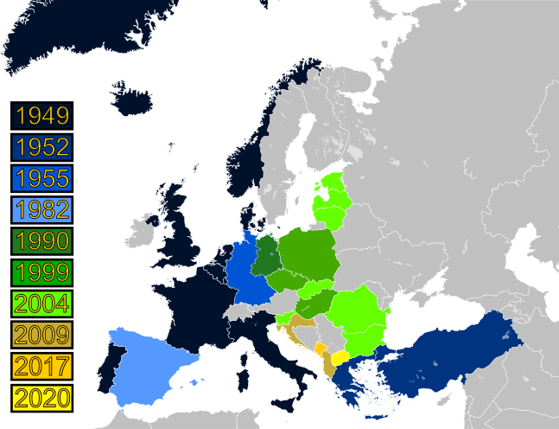

#### Adriatic Charter

The [Adriatic](https://en.wikipedia.org/wiki/Adriatic_Sea) Charter is an association formed by [Albania,](https://en.wikipedia.org/wiki/Albania) [Croati](https://en.wikipedia.org/wiki/Croatia)a, [North Macedonia](https://en.wikipedia.org/wiki/North_Macedonia) and the [United States](https://en.wikipedia.org/wiki/United_States) for the purpose of aiding their attempts to join [NATO](https://en.wikipedia.org/wiki/NATO). The Charter was signed on 2 May 2003 in [Tirana](https://en.wikipedia.org/wiki/Tirana) under the aegis of the [United States.](https://en.wikipedia.org/wiki/United_States) The role of the United States has caused some confusion; in discussions in the other member states, the Charter is often called the U.S.-Adriatic Charter. In September 2008 [Montenegro](https://en.wikipedia.org/wiki/Montenegro) and [Bosnia and Herzegovina](https://en.wikipedia.org/wiki/Bosnia_and_Herzegovina) were invited to join the Charter and joined on December 4, 2008 [Serbia](https://en.wikipedia.org/wiki/Serbia) accepted observer status at the same time.

# Current status

Bosnia and Herzegovina is the only country with a [Membership Action Plan](https://en.wikipedia.org/wiki/Membership_Action_Plan), which together with Georgia, were named NATO "aspirant countries" at the North Atlantic Council meeting on 7 December 2011.Ukraine was recognized as an aspirant country after the [2014 Ukrainian revolutio](https://en.wikipedia.org/wiki/Revolution_of_Dignity)n. In 2022, NATO signed protocols with Sweden and Finland on their accession following the [Russian invasion of Ukraine](https://en.wikipedia.org/wiki/2022_Russian_invasion_of_Ukraine).

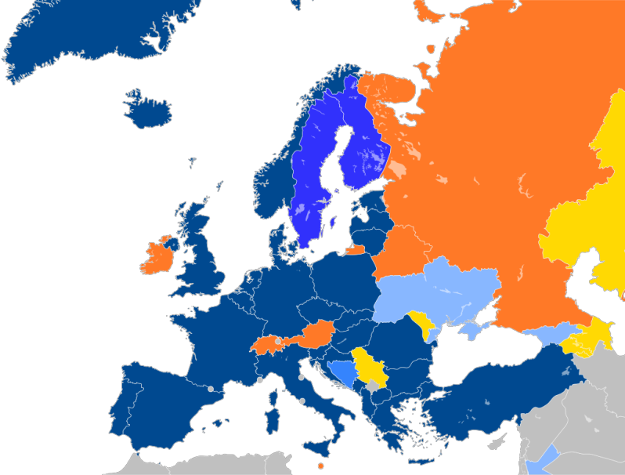

|  |
| --- |
| Map of Europe with countries |
| in six different colors based on |
| their affiliation with NATO as follows:  Members of NATO  Accession protocol signed  Membership Action Plan  Enhanced Opportunity Partner Individual Partnership Action Plan Partnership for Peace |

#### Bosnia and Herzegovina

The [1995 NATO bombing of Bosnia and Herzegovina](https://en.wikipedia.org/wiki/Operation_Deliberate_Force) targeted the [Bosnian Serb Army](https://en.wikipedia.org/wiki/Army_of_Republika_Srpska) and together with international pressure led to the resolution of the [Bosnian War](https://en.wikipedia.org/wiki/Bosnian_War) and the signing of the [Dayton](https://en.wikipedia.org/wiki/Dayton_Agreement) [Agreement](https://en.wikipedia.org/wiki/Dayton_Agreement) in 1995. Since then, NATO has led the [Implementation Force](https://en.wikipedia.org/wiki/Implementation_Force) and [Stabilization Force,](https://en.wikipedia.org/wiki/Stabilisation_Force_in_Bosnia_and_Herzegovina) and other peacekeeping efforts in the country.

On 22 April 2010, NATO agreed to launch the [*Membership Action Plan*](https://en.wikipedia.org/wiki/Membership_Action_Plan) for Bosnia and Herzegovina, but with certain conditions attached.

The conditions of the MAP, however, stipulated that no Annual National Programme could be launched until 63 military facilities are transferred from [Bosnia's political divisions](https://en.wikipedia.org/wiki/Political_divisions_of_Bosnia_and_Herzegovina) to the central government, which is one of the conditions for the [OHR closure.](https://en.wikipedia.org/wiki/High_Representative_for_Bosnia_and_Herzegovina#Conditions_for_closure_of_the_Office_of_the_High_Representative) The leadership of the [Republika](https://en.wikipedia.org/wiki/Republika_Srpska) [Srpska](https://en.wikipedia.org/wiki/Republika_Srpska) has opposed this transfer as a loss of autonomy. All movable property, including all weapons and other army equipment, is fully registered as the property of the country starting 1 January 2006. A ruling of the [Constitutional Court of Bosnia and Herzegovina](https://en.wikipedia.org/wiki/Constitutional_Court_of_Bosnia_and_Herzegovina) on 6 August 2017 decided that a disputed military facility in [Han Pijesak](https://en.wikipedia.org/wiki/Han_Pijesak) is to be registered as property of Bosnia and Herzegovina. Despite the fact that all immovable property is not fully registered, NATO approved the activation of the [Membership Action Plan](https://en.wikipedia.org/wiki/Membership_Action_Plan) for Bosnia and Herzegovina, and called on Bosnia to submit an Annual National Programme on 5 December 2018.

A February 2017 poll showed that 59% of the country supports NATO membership, but results were very divided depending on ethnic groups. While 84% of those who identified as [Bosniak](https://en.wikipedia.org/wiki/Bosniak) or [Croat](https://en.wikipedia.org/wiki/Croat) supported NATO membership, only 9% of those who identified as [Serb](https://en.wikipedia.org/wiki/Serb) did. Bosnian chances of joining NATO may depend on Serbia's attitude towards the alliance, since the leadership of Republika Srpska might be reluctant to go against Serbian interests.

#### Finland

For much of the Cold War, [Finland](https://en.wikipedia.org/wiki/Finland)'s relationship with NATO and the Soviet Union followed the [Paasikivi–Kekkonen doctrine,](https://en.wikipedia.org/wiki/Paasikivi%25E2%2580%2593Kekkonen_doctrine) where the country joined neither the Western nor Eastern blocs, and limited its military activities. Since the 1990s and across multiple governments, the Finnish position was that joining NATO was unnecessary and it was preferable to retain an independent defence policy. Finland joined the [Partnership for Peace](https://en.wikipedia.org/wiki/Partnership_for_Peace) in 1994, and has provided peacekeeping forces to both NATO's Kosovo and Afghanistan missions in the early 2000s.Finland has regularly purchased military equipment from members of the alliance and newly-procured local equipment is required to follow NATO international standards.

The prospect of a full Russian invasion of Ukraine in 2022, however, led Prime Minister [Sanna Marin](https://en.wikipedia.org/wiki/Sanna_Marin) to say in January 2022 that Finland reserved the option of applying NATO membership if it chooses to do so, but that it was "very unlikely" it would happen during her term as Prime Minister.

After [Russia did invade Ukraine,](https://en.wikipedia.org/wiki/Russo-Ukrainian_War) she reiterated that while Finland was "not currently facing an immediate military threat," joining NATO was still a possibility, noting that "the debate on NATO membership in Finland will change." On 25 February, a Russian Foreign Ministry spokesperson threatened [Finland](https://en.wikipedia.org/wiki/Finland) and [Sweden](https://en.wikipedia.org/wiki/Sweden) with "military and political consequences" if they attempted to join NATO.Both countries had attended the emergency NATO summit as members of NATO's [Partnership for Peace](https://en.wikipedia.org/wiki/Partnership_for_Peace) and both had condemned the invasion and had provided assistance to Ukraine. Marin attended other meetings in the following weeks, including ones with Swedish leaders regarding coordinating their decisions on NATO, which she suggested would be concluded in a matter of "weeks, not months".In March 2022, opinion polling showed a clear majority of Finns supported joining NATO after the invasion.

And on 17 May, the [Parliament of Finland](https://en.wikipedia.org/wiki/Parliament_of_Finland) voted 188–8 in favor of joining NATO, and a formal application was submitted for NATO membership on 18 May 2022.

#### Sweden

In 1949, [Sweden](https://en.wikipedia.org/wiki/Sweden) chose not to join NATO and declared a security policy aiming for [non-](https://en.wikipedia.org/wiki/Swedish_neutrality) [alignment](https://en.wikipedia.org/wiki/Swedish_neutrality) in peace and neutrality in war. A modified version now qualifies non- alignment in peace for possible neutrality in war. This position was maintained without much discussion during the [Cold War.](https://en.wikipedia.org/wiki/Cold_War) Since the 1990s, however, there has been an active debate in Sweden on the question of NATO membership in the [post–](https://en.wikipedia.org/wiki/Post%25E2%2580%2593Cold_War_era) [Cold War era.](https://en.wikipedia.org/wiki/Post%25E2%2580%2593Cold_War_era) These ideological divides were visible in November 2006 when Sweden could either buy two new transport planes or join NATO's plane pool, and in December 2006, when Sweden was invited to join the [NATO Response Force.](https://en.wikipedia.org/wiki/NATO_Response_Force) Sweden has been an active participant in NATO-led missions in Bosnia ([IFOR](https://en.wikipedia.org/wiki/Implementation_Force) and [SF](https://en.wikipedia.org/wiki/Stabilisation_Force_in_Bosnia_and_Herzegovina)OR), Kosovo ([KFOR),](https://en.wikipedia.org/wiki/Kosovo_Force) Afghanistan ([ISAF](https://en.wikipedia.org/wiki/International_Security_Assistance_Force)), and Libya ([Operation Unified Prote](https://en.wikipedia.org/wiki/Operation_Unified_Protector)ctor).

[Russia's military actions in Ukraine](https://en.wikipedia.org/wiki/Russo-Ukrainian_War), first in 2014 and later in 2022, have caused most major political parties in Sweden to at least re-evaluate their positions on NATO membership, and many moved to support Swedish membership. Support for NATO membership over this period steadily increased, with polling by the [SOM Institute](https://en.wikipedia.org/wiki/SOM_Institute) showing it growing from 17% to 31% between 2012 and 2015. Events like the [*annexation of Crimea*](https://en.wikipedia.org/wiki/Annexation_of_Crimea_by_the_Russian_Federation) and reports of [*Russian submarine activity*](https://en.wikipedia.org/wiki/Swedish_submarine_incidents#After_the_cold_war) in 2014, as well as a 2013 report that Sweden could hold out for only a week if attacked, were credited with that rise in support. A May 2017 poll by [Pew](https://en.wikipedia.org/wiki/Pew_Research_Center) also showed that 48% supported membership, and in November 2020, they showed that 65% of Swedes viewed NATO positively, the highest percent of any non-NATO member polled. A Novus poll conducted in late February 2022 found 41% in favor of NATO membership and 35% opposed. On 4 March 2022, a poll was released that showed 51% support NATO membership, the first time a poll has shown a majority supporting this position.

#### Ukraine

[Ukraine](https://en.wikipedia.org/wiki/Ukraine)'s present and future relationship with NATO has been politically divisive, and is part of a larger debate between Ukraine's political and cultural ties to both the European Union and Russia. It established ties to the alliance with a *NATO–Ukraine Action Plan* on 22 November 2002, and joined NATO's [*Partnership for Peace*](https://en.wikipedia.org/wiki/Partnership_for_Peace) initiative in February 2005.Then in April 2005, Ukraine entered into the *Intensified Dialogue* program with NATO. In March 2008, under [Ukrainian President](https://en.wikipedia.org/wiki/President_of_Ukraine) [Viktor Yushchenko](https://en.wikipedia.org/wiki/Viktor_Yushchenko) and [Prime Minister](https://en.wikipedia.org/wiki/Prime_Minister_of_Ukraine) [Yulia Tymoshenko,](https://en.wikipedia.org/wiki/Yulia_Tymoshenko) Ukraine sent an official letter of application for a [*Membership Action Plan*](https://en.wikipedia.org/wiki/Membership_Action_Plan) *(MAP)*, the first step in joining NATO. These leaders however guaranteed their opposition that membership in any military alliance would not pass without public approval in a referendum. This idea had gained support from a number of NATO leaders, particularly those in [Central and Eastern E](https://en.wikipedia.org/wiki/Central_and_Eastern_Europe)urope.Russian leaders like Prime Minister and President-Elect [Dmitry Medvedev](https://en.wikipedia.org/wiki/Dmitry_Medvedev) made clear their opposition to Ukraine membership, and leading up to the April [2008 Bucharest](https://en.wikipedia.org/wiki/2008_Bucharest_summit) [summit](https://en.wikipedia.org/wiki/2008_Bucharest_summit) their emissary actively lobbied against a Ukrainian MAP. After some debate among members at the summit, NATO Secretary General [Jaap de Hoop Scheffer](https://en.wikipedia.org/wiki/Jaap_de_Hoop_Scheffer) declared in a press conference that Ukraine, together with Georgia, would someday join NATO, but neither would begin [Membership Action Plan](https://en.wikipedia.org/wiki/Membership_Action_Plan)s. At this summit, Russian President [Vladimir Puti](https://en.wikipedia.org/wiki/Vladimir_Putin)n, in his last international speech before switching jobs with Medvedev, listed his grievances with NATO, and called Ukrainian membership "a direct threat" to his country.

On 8 October 2020, during a meeting with [Prime Minister](https://en.wikipedia.org/wiki/Prime_Minister_of_the_United_Kingdom) [Boris Johnson](https://en.wikipedia.org/wiki/Boris_Johnson) in [London,](https://en.wikipedia.org/wiki/London) [President](https://en.wikipedia.org/wiki/President_of_Ukraine) [Volodymyr Zelenskyy](https://en.wikipedia.org/wiki/Volodymyr_Zelenskyy) stated that Ukraine needs a NATO [Membership](https://en.wikipedia.org/wiki/Membership_Action_Plan) [Action Plan](https://en.wikipedia.org/wiki/Membership_Action_Plan) (MAP), as NATO membership will contribute to Ukraine's security and defense. In April 2021, following a Russian troop buildup near the Ukraine border, Zelenskyy repeated this request in a call with NATO Secretary-General Jens Stoltenberg, saying that "NATO is the only way to end the war in Donbas" and that entry into the MAP "will be a real signal for Russia."

Several weeks after the 2022 Russian invasion of Ukraine, former US Ambassador to NATO [Ivo Daalder](https://en.wikipedia.org/wiki/Ivo_Daalder) called for Ukraine to be offered membership, in a piece published in [*The Atlantic*](https://en.wikipedia.org/wiki/The_Atlantic). Since the invasion, calls for NATO membership for Ukraine have escalated across both Ukraine and NATO countries.On 30 September 2022,Ukraine formally submitted an application for Nato Membership.

#### Georgia

[Georgia](https://en.wikipedia.org/wiki/Georgia_(country)) moved quickly following the [Rose Revolution](https://en.wikipedia.org/wiki/Rose_Revolution) in 2003 to seek closer ties with NATO(although the previous administration had also indicated that they desired NATO membership a year before the revolution took place). Georgia's northern neighbor, [Russ](https://en.wikipedia.org/wiki/Russia)ia, opposed the closer ties, including those expressed at the [2008](https://en.wikipedia.org/wiki/2008_Bucharest_summit) [Bucharest summit](https://en.wikipedia.org/wiki/2008_Bucharest_summit) where NATO members promised that Georgia would eventually join the organization. In June 2014, diplomats from NATO suggested that while a MAP was unlikely, a package of "reinforced cooperation" agreements was a possible compromise.

On 29 September 2020, [NATO Secretary General](https://en.wikipedia.org/wiki/NATO_Secretary_General) [Jens Stoltenberg](https://en.wikipedia.org/wiki/Jens_Stoltenberg) called on Georgia to use every opportunity to move closer to the Alliance and speed up preparations for membership. Stoltenberg stressed that earlier that year, the Allies agreed to further strengthen the NATO-Georgia partnership, and that NATO welcomed the progress made by Georgia in carrying out reforms, modernizing its armed forces and strengthening democracy.Georgian President [Salome Zourabichvili](https://en.wikipedia.org/wiki/Salome_Zourabichvili), who took office in 2018, has conceded that NATO membership might not be possible while Russia occupies Georgian territory, and has sought to focus on European Union membership which [Georgia submitted its application for](https://en.wikipedia.org/wiki/Georgia%25E2%2580%2593European_Union_relations) in May 2022.

* 1. **Membership debates**

The Soviet Union was the primary ideological adversary for NATO during the Cold War. Following its dissolution, several states which maintained [neutrality](https://en.wikipedia.org/wiki/Neutrality_(international_relations)) during the Cold War or were [post-Soviet states](https://en.wikipedia.org/wiki/Post-Soviet_states) increased their ties with Western institutions, including a number of them requesting to join NATO. The 2022 Russian invasion of Ukraine reignited debate surrounding NATO membership in several countries.

#### Austria

Shortly after West Germany's accession to NATO, the parties agr[eed to the Austrian](https://en.wikipedia.org/wiki/Austrian_State_Treaty) [State Treaty](https://en.wikipedia.org/wiki/Austrian_State_Treaty) in May 1955, which was largely based on the Moscow Memorandum signed the previous month between Austria and the Soviet Union. While the treaty itself did not commit Austria to neutrality, this was subsequently enshrined into Austria's constitution that October with the [Declaration of Neutrality](https://en.wikipedia.org/wiki/Declaration_of_Neutrality). The Declaration prohibits Austria from joining a military alliance, from hosting foreign military bases within its borders, and from participating in a war

Membership of Austria in the [European Union](https://en.wikipedia.org/wiki/European_Union) (or its predecessor organizations) was controversial due to the Austrian commitment to neutrality. Austria only joined in [1995](https://en.wikipedia.org/wiki/1995_enlargement_of_the_European_Union), together with two [Nordic countries](https://en.wikipedia.org/wiki/Nordic_countries) that had also declared their neutrality in the Cold War (Sweden and Finland). Austria joined NATO's [Partnership for Peace](https://en.wikipedia.org/wiki/Partnership_for_Peace) in 1995, and participates in NATO's [Euro-Atlantic Partnership Council](https://en.wikipedia.org/wiki/Euro-Atlantic_Partnership_Council). The [Austrian](https://en.wikipedia.org/wiki/Military_of_Austria) [military](https://en.wikipedia.org/wiki/Military_of_Austria) also participates in the [United Nations peacekeeping operations](https://en.wikipedia.org/wiki/United_Nations_Peacekeeping_Operations) and has deployments in several countries as of 2022, including [Kosovo,](https://en.wikipedia.org/wiki/Kosovo) [Lebanon,](https://en.wikipedia.org/wiki/Lebanon) and [Bosnia](https://en.wikipedia.org/wiki/Bosnia_and_Herzegovina) [and Herzegovina,](https://en.wikipedia.org/wiki/Bosnia_and_Herzegovina) where it has led the [EUFOR mission there](https://en.wikipedia.org/wiki/Operation_Althea) since 2009.

Current Chancellor [Karl Nehammer](https://en.wikipedia.org/wiki/Karl_Nehammer) has rejected the idea of reopening Austria's neutrality by joining NATO and membership is not widely popular with the Austrian public. According to a survey in May 2022 by the [Austria Press Agenc](https://en.wikipedia.org/wiki/Austria_Press_Agency)y, only 14% of Austrians surveyed supported joining NATO, while 75% were opposed.

#### Kosovo

According to [Minister of Foreign Affairs](https://en.wikipedia.org/wiki/Ministry_of_Foreign_Affairs_(Kosovo)) [Enver Hoxhaj,](https://en.wikipedia.org/wiki/Enver_Hoxhaj) integration with NATO is a priority for [Kosovo,](https://en.wikipedia.org/wiki/Kosovo) which [declared independence from Serbia](https://en.wikipedia.org/wiki/2008_Kosovo_declaration_of_independence) in 2008 Kosovo submitted an application to join the PfP program in July 2012,and Hoxhaj stated in 2014 that the country's goal is to be a NATO member by 2022. In December 2018, [Kosovar Prime Minister Ramush](https://en.wikipedia.org/wiki/Prime_Minister_of_Kosovo) [Haradinaj](https://en.wikipedia.org/wiki/Prime_Minister_of_Kosovo) stated that Kosovo will apply for NATO membership after the formation of the [Kosovo Armed Forces.](https://en.wikipedia.org/wiki/Kosovo_Armed_Forces) Kosovo's lack of [recognition](https://en.wikipedia.org/wiki/International_recognition_of_Kosovo) by four [NATO member st](https://en.wikipedia.org/wiki/Member_states_of_NATO)ates—[Greece,](https://en.wikipedia.org/wiki/Greece) [Romania](https://en.wikipedia.org/wiki/Romania), [Spain,](https://en.wikipedia.org/wiki/Spain) and [Slovakia—c](https://en.wikipedia.org/wiki/Slovakia)ould impede its accession. [United Nations](https://en.wikipedia.org/wiki/United_Nations) membership, which Kosovo does not have, is considered to be necessary for NATO membership.

In February 2022, during the 2022 Russian invasion of Ukraine, Minister of Defense requested a permanent US military base in the country and an accelerated accession process to the organization, citing an "immediate need to guarantee peace, security and stability in the Western Balkans". On 3 March 2022, a resolution was passed by Kosovo's Parliament requesting that the government "take all necessary steps to join NATO[, European](https://en.wikipedia.org/wiki/European_Union) [Union,](https://en.wikipedia.org/wiki/European_Union) [Council of Europe](https://en.wikipedia.org/wiki/Council_of_Europe) and other international organizations".

* + 1. **Moldova**

[Moldova](https://en.wikipedia.org/wiki/Moldova) gained independence in 1991 following the collapse of the Soviet Union. The [country's current constitution](https://en.wikipedia.org/wiki/Constitution_of_Moldova) was adopted in 1994, and forbids the country from joining a military alliance, but some politicians, such as former Moldovan Minister of Defence [Vitalie Marinuța](https://en.wikipedia.org/wiki/Vitalie_Marinu%25C8%259Ba), have suggested joining NATO as part of a larger European integration. Moldova joined NATO's [Partnership for Peace](https://en.wikipedia.org/wiki/Partnership_for_Peace) in 1994, and initiated an Individual Partnership Action Plan in 2010.They also participate in NATO's peacekeeping force in Kosovo.Following the 2014 [annexation of Crimea by Russia,](https://en.wikipedia.org/wiki/Annexation_of_Crimea_by_the_Russian_Federation) NATO officials warned that [Russia](https://en.wikipedia.org/wiki/Russia) [might seek to annex](https://en.wikipedia.org/wiki/Proposed_Russian_annexation_of_Transnistria) [Transnistria](https://en.wikipedia.org/wiki/Transnistria), a breakaway Moldovan region.This separatist issue could preclude Moldova from joining NATO.A poll in December 2018 found that, if given the choice in a referendum, 22% of Moldovans would vote in favor of joining NATO, while 32% would vote against it and 21% would be unsure. Some Moldova politicians, including former [Prime Minister](https://en.wikipedia.org/wiki/Prime_Minister_of_Moldova) [Iurie Leancă](https://en.wikipedia.org/wiki/Iurie_Leanc%25C4%2583), have also supported the idea of [unifying with neighboring Romania,](https://en.wikipedia.org/wiki/Unification_of_Moldova_and_Romania) which Moldova shares a language and much of its history with, and a poll in April 2021 found that 43.9% of those surveyed supported that idea. [Romania](https://en.wikipedia.org/wiki/Romania) is a current member of both NATO and the European Union.

#### Malta

When the North Atlantic Treaty was signed in 1949, the Mediterranean island of [Malta](https://en.wikipedia.org/wiki/Malta) was a dependent territory of the United Kingdom, one of the treaty's original signatories. As such, the [Crown Colony of Malta](https://en.wikipedia.org/wiki/Crown_Colony_of_Malta) shared the UK's international memberships, including NATO. When Malta gained independence in 1964, prime minister [George Borg Olivier](https://en.wikipedia.org/wiki/George_Borg_Olivier) wanted the country to join NATO. Olivier was concerned that the presence of the NATO headquarters in Malta, without the security guarantees that NATO membership entailed, left the country to be vulnerable target. Maltese foreign policy changed notably in 2004, when the country joined the

European Union, and it re-joined the EAPC and PfP programs in 2008, pointing to a change in the island's [foreign relations.](https://en.wikipedia.org/wiki/Foreign_relations_of_Malta) Since re-joining, Malta has been building its relations with NATO and getting involved in wider projects including the PfP Planning and Review Process and the [NATO Science for Peace and Security](https://en.wikipedia.org/wiki/NATO_Science_for_Peace_and_Security) Program.

NATO membership is not supported by any of the country's political parties. Polling done by the island-nation's [Ministry of Foreign Affairs](https://en.wikipedia.org/wiki/Ministry_for_Foreign_and_European_Affairs_(Malta)) found in February 2022 that 63% of those surveyed supported the island's neutrality, and only 6% opposed the policy, with 14% undecided. A Eurobarometer survey in May 2022 found that 75% of Maltese would however support greater military cooperation within the European Union.

#### Serbia

[Yugoslavia](https://en.wikipedia.org/wiki/Socialist_Federal_Republic_of_Yugoslavia)'s [communist government](https://en.wikipedia.org/wiki/Communist_government) sided with the [Eastern Bloc](https://en.wikipedia.org/wiki/Eastern_Bloc) at the beginning of the [Cold War](https://en.wikipedia.org/wiki/Cold_War), but pursued a policy of [neutrality](https://en.wikipedia.org/wiki/Neutrality_(international_relations)) following the [Tito–Stalin split](https://en.wikipedia.org/wiki/Tito%25E2%2580%2593Stalin_split) in 1948. It was a [founding member of the Non-Aligned Movement](https://en.wikipedia.org/wiki/Yugoslavia_and_the_Non-Aligned_Movement) in 1961. Since [that country's](https://en.wikipedia.org/wiki/Breakup_of_Yugoslavia) [dissolution](https://en.wikipedia.org/wiki/Breakup_of_Yugoslavia) most of its [successor states](https://en.wikipedia.org/wiki/Succession_of_states) have joined NATO, but the largest of them, [Serbi](https://en.wikipedia.org/wiki/Serbia)a, has maintained Yugoslavia's policy of neutrality.

The [NATO intervention in Bosnia and Herzegovina](https://en.wikipedia.org/wiki/NATO_intervention_in_Bosnia_and_Herzegovina) in 1992 against [Bosnia-Serbian](https://en.wikipedia.org/wiki/Army_of_Republika_Srpska) [forces](https://en.wikipedia.org/wiki/Army_of_Republika_Srpska) and the [NATO bombing](https://en.wikipedia.org/wiki/NATO_bombing_of_Yugoslavia) of targets in Serbia during the [Kosovo War](https://en.wikipedia.org/wiki/Kosovo_War) in 1999 resulted in strained relations between Serbia and NATO.After the overthrow of President [Slobodan Milošević](https://en.wikipedia.org/wiki/Slobodan_Milo%25C5%25A1evi%25C4%2587) Serbia wanted to improve its relations with NATO, though membership in the military alliance remained highly controversial among political parties and society. In the years under Prime Minister [Zoran Đinđić](https://en.wikipedia.org/wiki/Zoran_%25C4%2590in%25C4%2591i%25C4%2587) the country (then [Serbia and Montenegr](https://en.wikipedia.org/wiki/Serbia_and_Montenegro)o) did not rule out joining NATO, but after [Đinđić's assassination](https://en.wikipedia.org/wiki/Assassination_of_Zoran_%25C4%2590in%25C4%2591i%25C4%2587) in 2003 Serbia increasingly started preferring a course of military neutrality. [Serbia's Parliament](https://en.wikipedia.org/wiki/National_Assembly_(Serbia)) passed a resolution in 2007 which declared their [military neutrality](https://en.wikipedia.org/wiki/Neutral_country) until such time as a referendum was held on the issue. Relations with NATO were further strained following [Kosovo's declaration of](https://en.wikipedia.org/wiki/2008_Kosovo_declaration_of_independence) [independence](https://en.wikipedia.org/wiki/2008_Kosovo_declaration_of_independence) in 2008, while it was a [protectorate of the United Nations](https://en.wikipedia.org/wiki/United_Nations_Interim_Administration_Mission_in_Kosovo) with security support from NATO.

Serbia was invited to and joined NATO's [Partnership for Peace](https://en.wikipedia.org/wiki/Partnership_for_Peace) program during the [2006 Riga summi](https://en.wikipedia.org/wiki/2006_Riga_summit)t, and in 2008 was invited to enter the intensified dialog program whenever the country was ready.In April 2011 Serbia's request for an IPAP was approved by NATO, and Serbia submitted a draft IPAP in May 2013.The agreement was finalized on 15 January 2015. Serbian President [Aleksandar Vuci](https://en.wikipedia.org/wiki/Aleksandar_Vucic)c, in office since 2017, reiterated in March 2022 that his government was not interested in NATO membership. A poll that month suggested that 82% of Serbians opposed joining

NATO, while only 10% supported the idea.The minor [Serbian Renewal Movement,](https://en.wikipedia.org/wiki/Serbian_Renewal_Movement)

which has two seats in the [National Assembly](https://en.wikipedia.org/wiki/National_Assembly_(Serbia)), and the [Liberal Democratic Party,](https://en.wikipedia.org/wiki/Liberal_Democratic_Party_(Serbia))

which currently has none, remain the most vocal political parties in favor of NATO membership.The [Democratic Party](https://en.wikipedia.org/wiki/Democratic_Party_(Serbia)) abandoned its pro-NATO attitude, claiming the Partnership for Peace is enough.

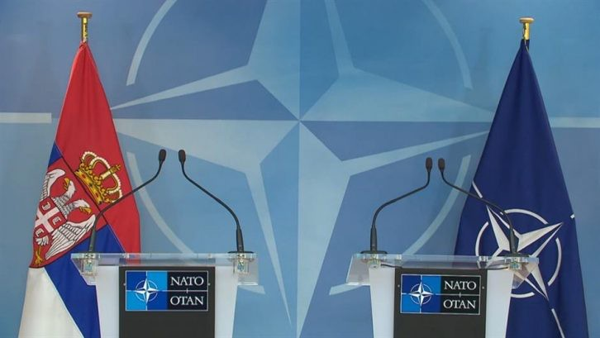Serbia maintains [close relations with Russi](https://en.wikipedia.org/wiki/Russia%25E2%2580%2593Serbia_relations)a, due to their shared Slavic and Eastern Orthodox culture but also due to its support on the Kosovo issue. Serbia and Belarus are the only European states which refused to impose sanctions on Russia in response to its [invasion of Ukraine.](https://en.wikipedia.org/wiki/2022_Russian_invasion_of_Ukraine)

## 3. History of United Nations Security Council

* 1. **Cold War**

Church House in London where the first Security Council Meeting took place on 17 January 1946The Security Council was largely paralyzed in its early **decades** by the [Cold War](https://en.wikipedia.org/wiki/Cold_War) between the US and USSR and their allies and the Council generally was only able to intervene in unrelated conflicts. (A notable exception was the 1950 Security Council resolution authorizing a US-led coalition to repel the [North Korean invasion](https://en.wikipedia.org/wiki/Korean_War) [of South Korea,](https://en.wikipedia.org/wiki/Korean_War) passed in the absence of the USSR.) In 1956, the [first UN](https://en.wikipedia.org/wiki/United_Nations_Emergency_Force) [peacekeeping force](https://en.wikipedia.org/wiki/United_Nations_Emergency_Force) was established to end the [Suez Crisi](https://en.wikipedia.org/wiki/Suez_Crisis)s; however, the UN was unable to intervene against the USSR's simultaneous invasion of Hungary following [that country's revolution](https://en.wikipedia.org/wiki/Hungarian_Revolution_of_1956).Cold War divisions also paralysed the Security Council's [Military Staff Committee,](https://en.wikipedia.org/wiki/Military_Staff_Committee) which had been formed by Articles 45–47 of the UN Charter to oversee UN forces and create UN military bases. The committee continued to exist on paper but largely abandoned its work in the mid-1950s.

In 1960, the UN deployed the [United Nations Operation in the Congo](https://en.wikipedia.org/wiki/United_Nations_Operation_in_the_Congo) (UNOC), the largest military force of its early decades, to restore order to the breakaway [State of](https://en.wikipedia.org/wiki/State_of_Katanga) [Katanga,](https://en.wikipedia.org/wiki/State_of_Katanga) restoring it to the control of the [Democratic Republic of the Congo](https://en.wikipedia.org/wiki/Democratic_Republic_of_the_Congo) by 1964. However, the Security Council found itself bypassed in favour of direct negotiations between the superpowers in some of the decade's larger conflicts, such as the [Cuban](https://en.wikipedia.org/wiki/Cuban_Missile_Crisis)

[Missile Crisis](https://en.wikipedia.org/wiki/Cuban_Missile_Crisis) or the [Vietnam War.](https://en.wikipedia.org/wiki/Vietnam_War) Focusing instead on smaller conflicts without an immediate Cold War connection, the Security Council deployed the [United Nations](https://en.wikipedia.org/wiki/United_Nations_Temporary_Executive_Authority) [Temporary Executive Authority](https://en.wikipedia.org/wiki/United_Nations_Temporary_Executive_Authority) in [West New Guinea](https://en.wikipedia.org/wiki/West_New_Guinea) in 1962 and the [United Nations](https://en.wikipedia.org/wiki/United_Nations_Peacekeeping_Force_in_Cyprus) [Peacekeeping Force in Cyprus](https://en.wikipedia.org/wiki/United_Nations_Peacekeeping_Force_in_Cyprus) in 1964, the latter of which would become one of the UN's longest-running peacekeeping missions.

On 25 October 1971, over US opposition, but with the support of many [Third World](https://en.wikipedia.org/wiki/Third_World) nations, along with the [Socialist People's Republic of Albani](https://en.wikipedia.org/wiki/Socialist_People%2527s_Republic_of_Albania)a, the mainland, communist [People's Republic of China](https://en.wikipedia.org/wiki/People%2527s_Republic_of_China) was given the Chinese seat on the Security Council in place of the [Republic of Chin](https://en.wikipedia.org/wiki/Republic_of_China)a; the vote was widely seen as a sign of waning US influence in the organization. With an increasing Third World presence and the failure of UN mediation in conflicts in the [Middle East,](https://en.wikipedia.org/wiki/Six-Day_War) [Vietnam](https://en.wikipedia.org/wiki/Vietnam_War) and [Kashmir,](https://en.wikipedia.org/wiki/Indo-Pakistani_War_of_1965) the UN increasingly shifted its attention to its ostensibly secondary goals of economic development and cultural exchange. By the 1970s, the UN budget for social and economic development was far greater than its budget for peacekeeping.

* 1. **Post-Cold War**

After the Cold War, the UN saw a radical expansion in its peacekeeping duties, taking on more missions in ten years than it had in its previous four decades. Between 1988 and 2000, the number of adopted Security Council resolutions more than doubled, and the peacekeeping budget increased more than tenfold. The UN negotiated an end to the [Salvadoran Civil War](https://en.wikipedia.org/wiki/Salvadoran_Civil_War), launched a successful [peacekeeping mission in](https://en.wikipedia.org/wiki/United_Nations_Transition_Assistance_Group) [Namibi](https://en.wikipedia.org/wiki/United_Nations_Transition_Assistance_Group)a, and oversaw democratic elections in post-[apartheid](https://en.wikipedia.org/wiki/Apartheid_in_South_Africa) South Africa and post- [Khmer Rouge](https://en.wikipedia.org/wiki/Khmer_Rouge) Cambodia. In 1991, the Security Council demonstrated its renewed vigor by condemning the Iraqi [invasion of Kuwait](https://en.wikipedia.org/wiki/Invasion_of_Kuwait) on the same day of the attack and later authorizing a [US-led coalition](https://en.wikipedia.org/wiki/Gulf_War) that successfully repulsed the Iraqis. Undersecretary-General [Brian Urquhart](https://en.wikipedia.org/wiki/Brian_Urquhart) later described the hopes raised by these successes as a "false renaissance" for the organization, given the more troubled missions that followed.

Though the UN Charter had been written primarily to prevent aggression by one nation against another, in the early 1990s, the UN faced a number of simultaneous, serious crises within nations such as Haiti, Mozambique and the former Yugoslavia.The [UN mission to Bosnia](https://en.wikipedia.org/wiki/United_Nations_Protection_Force) faced "worldwide ridicule" for its indecisive and confused mission in the face of ethnic cleansing. In 1994, the [United Nations](https://en.wikipedia.org/wiki/United_Nations_Assistance_Mission_for_Rwanda) [Assistance Mission for Rwanda](https://en.wikipedia.org/wiki/United_Nations_Assistance_Mission_for_Rwanda) failed to intervene in the [Rwandan genocide](https://en.wikipedia.org/wiki/Rwandan_genocide) in the face of Security Council indecision.

In the late 1990s, UN-authorized international interventions took a wider variety of forms. The [UN mission](https://en.wikipedia.org/wiki/United_Nations_Mission_in_Sierra_Leone) in the 1991–2002 [Sierra Leone Civil War](https://en.wikipedia.org/wiki/Sierra_Leone_Civil_War) was supplemented by British [Royal Marines](https://en.wikipedia.org/wiki/Royal_Marines) and the UN-authorized [2001 invasion of Afghanistan](https://en.wikipedia.org/wiki/War_in_Afghanistan_(2001%25E2%2580%25932021)) was overseen by [NATO.](https://en.wikipedia.org/wiki/NATO) In 2003, the US [invaded Iraq](https://en.wikipedia.org/wiki/Iraq_War) despite failing to pass a UN Security Council resolution for authorization, prompting a new round of questioning of the organization's effectiveness. In the same decade, the Security Council intervened with peacekeepers in crises including the [War in Darfur](https://en.wikipedia.org/wiki/War_in_Darfur) in Sudan and the [Kivu conflict](https://en.wikipedia.org/wiki/Kivu_conflict) in the Democratic Republic of Congo. In 2013, [an internal review](https://en.wikipedia.org/wiki/Secretary-General%2527s_Internal_Review_Panel_on_United_Nations_Action_in_Sri_Lanka) of UN actions in [the](https://en.wikipedia.org/wiki/Alleged_war_crimes_during_the_final_stages_of_the_Sri_Lankan_Civil_War) [final battles](https://en.wikipedia.org/wiki/Alleged_war_crimes_during_the_final_stages_of_the_Sri_Lankan_Civil_War) of the [Sri Lankan Civil War](https://en.wikipedia.org/wiki/Sri_Lankan_Civil_War) in 2009 concluded that the organization had suffered "systemic failure".In November/December 2014, [Egypt](https://en.wikipedia.org/wiki/Egypt) presented a motion proposing an expansion of the NPT ([non-Proliferation Treaty),](https://en.wikipedia.org/wiki/Non-Proliferation_Treaty) to include [Israel](https://en.wikipedia.org/wiki/Israel) and [Iran;](https://en.wikipedia.org/wiki/Iran) this proposal was due to increasing hostilities and destruction in the Middle-East connected to the Syrian Conflict as well as others. All members of the Security Council are signatory to the NPT, and all permanent members are [nuclear weapons states.](https://en.wikipedia.org/wiki/Nuclear_weapons_states)

The UN's role in international [collective security](https://en.wikipedia.org/wiki/Collective_security) is defined by the UN Charter, which authorizes the Security Council to investigate any situation threatening international peace; recommend procedures for peaceful resolution of a dispute; call upon other member nations to completely or partially interrupt economic relations as well as sea, air, postal and radio communications, or to sever diplomatic relations; and enforce its decisions militarily, or by any means necessary. The Security Council also recommends the new Secretary-General to the General Assembly and recommends new states for admission as [member states of the United Nation](https://en.wikipedia.org/wiki/Member_states_of_the_United_Nations)s. The Security Council has traditionally interpreted its mandate as covering only military security, though US Ambassador [Richard Holbrooke](https://en.wikipedia.org/wiki/Richard_Holbrooke) controversially persuaded the body to pass a resolution on [HIV/AIDS in Africa](https://en.wikipedia.org/wiki/HIV/AIDS_in_Africa) in 2000.

Under [Chapter VI](https://en.wikipedia.org/wiki/Chapter_VI_of_the_United_Nations_Charter) of the Charter, "Pacific Settlement of Disputes", the Security Council "may investigate any dispute, or any situation which might lead to international friction or give rise to a dispute". The Council may "recommend appropriate procedures or methods of adjustment" if it determines that the situation might endanger international peace and security.These recommendations are generally considered to not be binding, as they lack an enforcement mechanism. A minority of scholars, such as [Stephen Zunes,](https://en.wikipedia.org/wiki/Stephen_Zunes) have argued that resolutions made under Chapter VI are "still directives by the Security Council and differ only in that they do not have the same stringent enforcement options, such as the use of military force".

Under [Chapter V](https://en.wikipedia.org/wiki/Chapter_VII_of_the_United_Nations_Charter)II, the council has broader power to decide what measures are to be taken in situations involving "threats to the peace, breaches of the peace, or acts of

aggression." In such situations, the council is not limited to recommendations but may take action, including the use of armed force "to maintain or restore international peace and security."[ This was the legal basis for UN armed action in Korea in 1950 during the Korean War and the use of coalition forces in Iraq and Kuwait in 1991 and Libya in 2011. Decisions taken under Chapter VII, such as [economic sanction](https://en.wikipedia.org/wiki/Economic_sanctions)s, are

binding on UN members; the Security Council is the only UN body with authority to issue binding resolutions.

The [Rome Statute of the International Criminal Court](https://en.wikipedia.org/wiki/Rome_Statute_of_the_International_Criminal_Court) recognizes that the Security Council has authority to refer cases to the Court in which the Court could not otherwise exercise jurisdiction.The Council exercised this power for the first time in March 2005, when it referred to the Court "the situation prevailing in [Darfur](https://en.wikipedia.org/wiki/Darfur) since 1 July 2002"; since Sudan is not a party to the Rome Statute, the Court could not otherwise have exercised jurisdiction. The Security Council made its second such referral in February 2011 when it asked the ICC to investigate the Libyan government's violent response to the [Libyan Civil War](https://en.wikipedia.org/wiki/2011_Libyan_Civil_War).

[Security Council Resolution 1674,](https://en.wikipedia.org/wiki/United_Nations_Security_Council_Resolution_1674) adopted on 28 April 2006, "reaffirms the provisions of paragraphs 138 and 139 of the 2005 [World Summit Outcome Document](https://en.wikipedia.org/wiki/World_Summit_Outcome_Document) regarding the responsibility to protect populations from genocide, war crimes, ethnic cleansing and crimes against humanity".The Security Council reaffirmed this [responsibility to](https://en.wikipedia.org/wiki/Responsibility_to_protect) [protect](https://en.wikipedia.org/wiki/Responsibility_to_protect) in [Resolution 1706](https://en.wikipedia.org/wiki/United_Nations_Security_Council_Resolution_1706) on 31 August of that year.These resolutions commit the Security Council to protect civilians in an armed conflict, including taking action against genocide, war crimes, ethnic cleansing and crimes against humanity.

## 4. United Nations Peacekeepers

After approval by the Security Council, the UN may send [peacekeepers](https://en.wikipedia.org/wiki/Peacekeeping) to regions where armed conflict has recently ceased or paused to enforce the terms of peace agreements and to discourage combatants from resuming hostilities. Since the UN does not maintain its own military, peacekeeping forces are voluntarily provided by member states. These soldiers are sometimes nicknamed "Blue Helmets" for their distinctive gear. The peacekeeping force as a whole received the [Nobel Peace Prize](https://en.wikipedia.org/wiki/Nobel_Peace_Prize) in 1988.

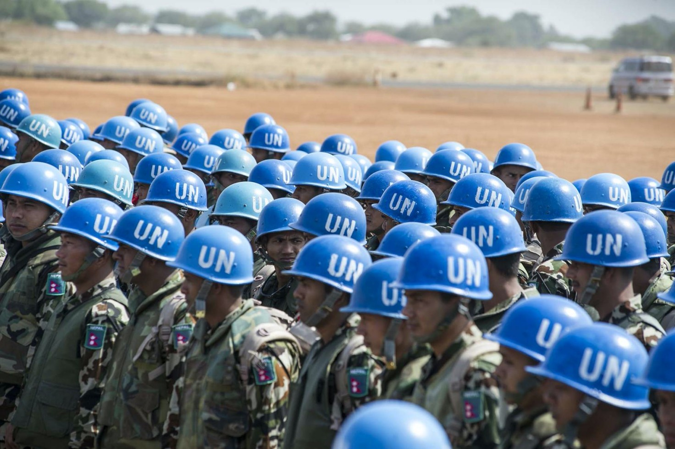

**Milestones**

**4 April 1949:** Signature of the North Atlantic Treaty by 12 founding members: Belgium, Canada, Denmark, France, Iceland, Italy, Luxembourg, the Netherlands, Norway, Portugal, the United Kingdom and the United States. Article 10 of the Treaty provides the basis for NATO’s “open door policy”.

**18 February 1952:** Accession of Greece and Türkiye.

**6 May 1955:** Accession of the Federal Republic of Germany.

**30 May 1982:** Spain joins the Alliance (and the integrated military structure in 1998).

**October 1990:** With the reunification of Germany, the new German Länder in the East become part of NATO.

**January 1994:** At the Brussels Summit, Allied leaders reaffirm that NATO remains open to the membership of other European countries.

**28 September 1995**: Publication of NATO Study on Enlargement.

**8-9 July 1997:** At the Madrid Summit, three partner countries – Czechia, Hungary and Poland – are invited to start accession talks.

**12 March 1999:** Accession of Czechia, Hungary and Poland, bringing the Alliance to 19 members.

**23-25 April 1999:** Launch of the Membership Action Plan (MAP) at the Washington Summit. (Bulgaria, Estonia, Latvia, Lithuania, Romania, Slovakia and Slovenia join the MAP.)

**14 May 2002:** NATO foreign ministers officially announce the participation of Croatia in the MAP at their meeting in Reykjavik, Iceland.

**May 2002:** President Leonid Kuchma announces Ukraine’s goal of eventual NATO membership.

**21-22 November 2002:** At the Prague Summit, seven partner countries – Bulgaria, Estonia, Latvia, Lithuania, Romania, Slovakia and Slovenia – are invited to start accession talks.

**26 March 2003:** Signing ceremony of the Accession Protocols of the seven invitees.

**29 March 2004:** Accession of Bulgaria, Estonia, Latvia, Lithuania, Romania, Slovakia

and Slovenia.

**21 April 2005:** Launch of the Intensified Dialogue on Ukraine’s aspirations to NATO membership and related reforms, at an informal meeting of foreign ministers in Vilnius, Lithuania.

**21 September 2006:** NATO foreign ministers in New York announce the decision to offer an Intensified Dialogue to Georgia.

**28-29 November 2006:** At the Riga Summit, Allied leaders state that invitations will be extended to MAP countries that fulfil certain conditions.

**2-4 April 2008:** At the Bucharest Summit, Allied leaders invite Albania and Croatia to start accession talks; assure the country known at the time as the former Yugoslav Republic of Macedonia that it will be invited once a solution to the issue of the country’s name has been reached with Greece; invite Bosnia and Herzegovina and Montenegro to start Intensified Dialogues; and agree that Georgia and Ukraine will become members in future.

**9 July 2008:** Accession Protocols for Albania and Croatia are signed. Allied foreign ministers agree that Georgia should develop an Annual National Programme under the auspices of the NATO-Georgia Commission.

**1 April 2009:** Accession of Albania and Croatia.

**4 December 2009:** NATO foreign ministers invite Montenegro to join the MAP.

**22 April 2010:** NATO foreign ministers invite Bosnia and Herzegovina to join the MAP, authorising the North Atlantic Council to accept the country’s first Annual National Programme only when the immovable property issue has been resolved.

**2 December 2015:** NATO foreign ministers meeting in Brussels invite Montenegro to start accession talks to join the Alliance, while encouraging further progress on reforms, especially in the area of rule of law. In a statement on NATO’s “open door” policy, ministers encourage Bosnia and Herzegovina to undertake the reforms

necessary for the country to realise its Euro-Atlantic aspirations and to activate its participation in MAP. Ministers also reiterate their decisions at Bucharest and subsequent decisions concerning Georgia, welcoming the progress the country has made in coming closer to the Alliance and expressing their determination to intensify support for Georgia.

**19 May 2016:** Allied ministers sign the Accession Protocol, following which Montenegro has ‘Invitee ’status and starts attending North Atlantic Council and other NATO meetings.

**5 June 2017:** Accession of Montenegro

**11 July 2018:** At the Brussels Summit, following the historic agreement between Athens and Skopje on the solution of the name issue, Allied leaders invite the government in Skopje to begin accession talks to join NATO. Full implementation of the agreement on the solution of the name issue is a condition for a successful conclusion of the accession process.

**5 December 2018:** Allied foreign ministers decide that NATO is ready to accept the submission of Bosnia and Herzegovina’s first Annual National Programme under the MAP. The registration of immovable defence property to the state remains essential.

**6 February 2019:** The Allies sign the Accession Protocol of the Republic of North Macedonia, following which the country takes part in NATO activities as an invitee.

**15 February 2019:** The Republic of North Macedonia is officially recognised by its constitutional name, following the full implementation of the agreement between Athens and Skopje.

**27 March 2020:** Accession of the Republic of North Macedonia

**18 May 2022:** In a meeting with Secretary General Jens Stoltenberg at NATO Headquarters, Finland and Sweden simultaneously submit their official letters of application to join the Alliance.

**29-30 June 2022:** Heads of State and Government from Finland, Georgia, Sweden and Ukraine, and the Defence Minister of Bosnia and Herzegovina take part in the NATO Summit in Madrid. NATO reaffirms its commitment to its “open door policy”, formally inviting Finland and Sweden to become members of NATO, and promising to step up support for Bosnia and Herzegovina, Georgia and Ukraine.

**4 July 2022:** Finland and Sweden complete accession talks at NATO Headquarters in Brussels.

**5 July 2022:** Allies sign the Accession Protocols for Finland and Sweden, making them official Invitees

**Chairboard’s Contact**

The delegates of Security Council can contact with us anytime needed.

***Chair***

GSM: +905522149656

E-mail: [cdefne463@gmail.com](mailto:cdefne463@gmail.com)

***Co-Chair***

GSM: +90 5536964133

[E-mail:ezgidd1224@gmail.com](mailto:ezgidd1224@gmail.com)

**Bibliography**

<https://news.un.org/en/story/2022/02/1112802>

[https://www.britannica.com/topic/United-Nations-Security-](https://www.britannica.com/topic/United-Nations-Security-Council/History)

[Council/History](https://www.britannica.com/topic/United-Nations-Security-Council/History)

<https://www.nato.int/cps/en/natolive/topics_49212.htm>

<http://internationalrelations.org/united-nations-security-council>

<https://www.britannica.com/event/United-Nations-Resolution-338>

<https://www.nato.int/cps/en/natolive/topics_49212.htm>

[https://www.un.org/securitycouncil/content/repertoire/actions#rel7](https://www.un.org/securitycouncil/content/repertoire/actions%252523rel7)

<https://en.wikipedia.org/wiki/Enlargement_of_NATO>

[https://www.globalresearch.ca/the-breakup-of-yugoslavia-and-the-](https://www.globalresearch.ca/the-breakup-of-yugoslavia-and-the-secession-of-kosovo/8012?pdf=8012)

[secession-of-kosovo/8012?pdf=8012](https://www.globalresearch.ca/the-breakup-of-yugoslavia-and-the-secession-of-kosovo/8012?pdf=8012)